**Chapter II - Referencing Files and Setting Options**

1. Defining Libraries (**first step** in setting up your SAS session – also can use programming statement to assign library names):

Reference a permanent SAS file – CHAPTER I

* Assigning librefs:
* **Use LIBNAME statement** (the SAS data library is assigned each time the program is submitted)
  + - Multiple **LIBNAME** statements can be used to assign as many as librefs as needed.
    - **LIBNAME** statement is global (remain in effects until modify, cancel them or end of this SAS session; but the contents of the library still exist)

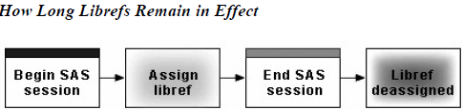

* + - Also, can reference SAS file to files that created by other software
    - Read or write these files by using the appropriate engines (for some file type SAS can automatically select the appropriate engines, some cannot)
    - SAS engine: a set of internal instructions that SAS uses for writing to and reading from files in a SAS library. (files – engine – SAS data library)
    - **Basic code (LIBNAME):**

**LIBNAME** *libref engine 'SAS-data-library'*;

Libref: CHAPTER I

*SAS-data-library* is the name of a SAS data library in which SAS data files are stored. The specification of the physical name of the library differs by operating environment.

*Engine* *is the name of a library engine that is supported in your operating environment.*

*E.g.:* **LIBNAME** rptdata SPSS 'g:\myspss.spss';

* **Use New Library window to assign:**

Libraries that are created with the New Library window can be automatically assigned at startup by selecting **Enable at Startup**. (Tool – New Library – “Enable at startup”)

* Verifying Librefs (**Second step**, check the log window)

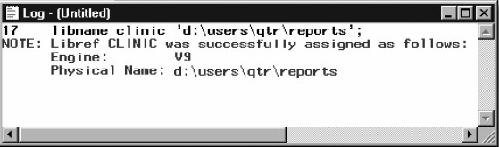

1. Viewing SAS Libraries Contents **by using SAS window**:

* Viewing the contents: double-click **Libraries** (or select **Libraries**→**Open** from the pop-up menu). Then select **View**→**Details**.
* Viewing a File’s contents: double-click the filename (or select the filename, and then select **Open** from the pop-up menu) – contents are displayed in the **VIEWTABLE** window（50题，Q9）
* Viewing File's properties, select the filename, and then select **Properties** from the pop-up menu.
* Viewing SAS LibrariesContents **by using SAS PROC CONTENTS**:
* Basic PROC CONTENTS step: (Quiz 5)

**PROC CONTENTS DATA=***SAS-file-specification* **NODS;**

**RUN;**

*SAS-file-specification* specifies an entire library or a specific SAS data set within a library. SAS-file-specification can take one of the following forms:

*<libref.>SAS-data-set* names one SAS data set to process.

*<libref.>_ALL***_** requests a listing of all files in the library. (Use a period (.) to append _**ALL**_ to the libref.)

**NODS** suppresses the printing of detailed information about each file when you specify _**ALL**_. (You can specify **NODS** only when you specify _**ALL**_.)

e.g.: **PROC** **CONTENTS** data=clinic. _ **ALL** _ **NODS**;

OR: **PROC** **CONTENTS** data=Maps.Afghani2;

* Use **PROC DATASETS** to view the contents (Same as PROC CONTENTS, only format differences):

**CONTENTS** **DATASETS**

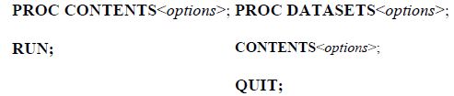

DATASETS: **PROC** **DATASETS**;

**CONTENTS** data=clinic. _**ALL**_ **NOBS**;

**RUN**；

CONTENTS: **PROC CONTENTS** data=clinic. _ **ALL** _ **NOBS**;

**RUN**;

* 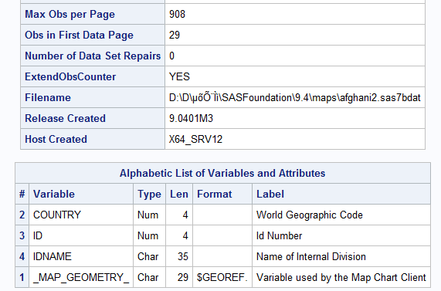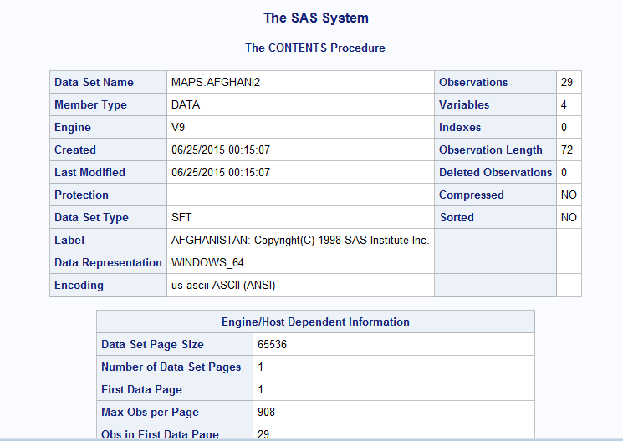 **Result：**
* Using **VARNUM:**

**PROC CONTENTS & PROC DATASETS** list variables *alphabetically*. **VARNUM** allow list name in the order of their *logical* position

* DATASETS: **PROC** datasets;

**CONTENTS** data=clinic.admit varnum;

**RUN**;

CONTENTS: **PROC CONTENTS** data=clinic.admit varnum;

**RUN**;

**PROC CONTENTS & PROC DATASETS VARNUM**

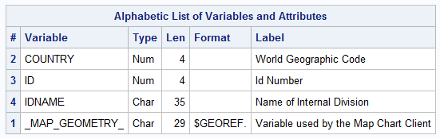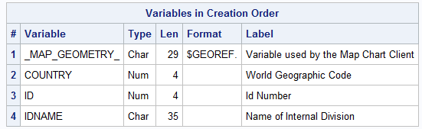

1. **Specifying Results Formats**

* **PROC PRINT** output is a **listing**

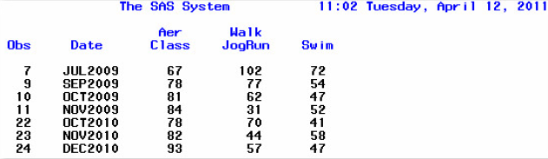

* HTML output:

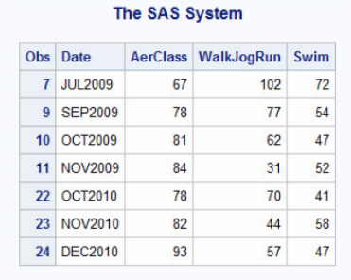

* Preference between HTML and **PROC** **PRINT** can be setted through: **Tools**→**Options**→**Preferences**

1. **Setting System Options**

* 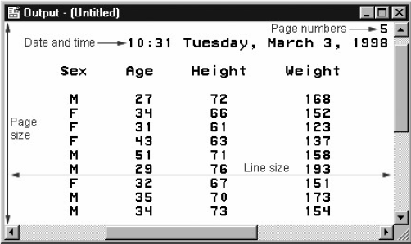Following appearance can be controlled:
* line size (the maximum width of the log and output)
* page size (the number of lines per printed page of output)
* the display of page numbers
* the display of date and time.
* The above options do not affect the appearance of HTML output.
* Change System Options

Make program easier to read, placed the **OPTIONS** statement outside of **DATA** and **PROC** steps (OPTIONS statement is global)

* Basic Program:
* **DATA | NODATA and NUMBER | NONUMBER** (suppress the display of page numbers and the date in the **PROC PRINT** output) (P63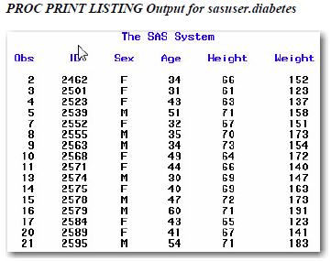)

Eg:

**OBS** **LISTING**;

**OPTION NONUMBER NODATE**;

**PROC PRINT** data=sasuser.admit;

**VAR** id sex age height weight;

**WHERE** age>=30;

**RUN**;

Eg:

**OPTION DATE**;

**PROC** **FREQ** data=sasuser.diabetes;

*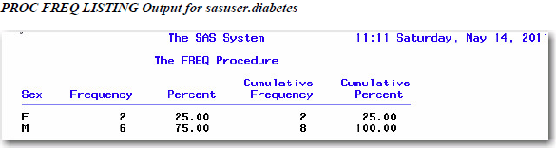***WHERE** fastgluc>=300;

**TABLE** sex;

**RUN**;

Eg:

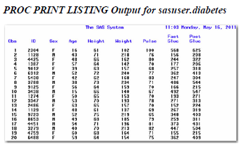**PROC** **PRINT** data=sasuser.diabetes;

**RUN**;

**OBS** **LISTING** close;

* **PAGENO** = Option

Specify the beginning page number, if don’t specify **PAGENO**=, output for **LISTING** report page number will start at 1

Eg: **ODS** **LISTING**;

**OPTION NODATE NUMBER PAGENO**=3;

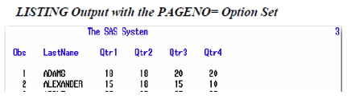**PROC** **PRINT** data=hrd.funddrive;

**RUN**;

**OBS** **LISTING** close;

* **PAGESIZE** = Option

Specify how many lines each page of output contains (each page of the output that the PRINT procedure produces contains 15 lines (including those used by the title, date, and so on))

Eg: **OPTION** **NUMBER** date **PAGESIZE** =15;

**PROC** **PRINT** data=sasuser.admit;

**RUN**;

* 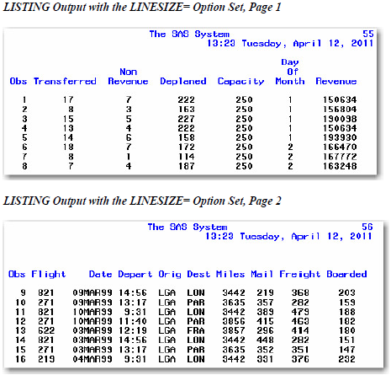**LINESIZE** = Option (alias LS=)

specifies the width of the print line for your procedure output and log. Observations that do not fit within the line size continue on a different line.

Eg: ODS listing;

**OPTION NUMBER LINESIZE** =64;

**PROC** **PRINT** data=flights.europe;

**RUN**;

**ODS LINESIZE** close;

* Handling Two-Digit Years Are Handled

**YEARCUTOFF** = Option

Specifies 100-year span is used to interpret two-digit year value from 1582A.D. to 20000 A.D.

Be awarded of the **YEARCUTOFF** = value to ensure that you are properly interpreting two-digit years in data lines

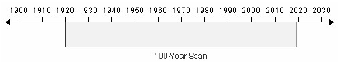

Eg.: options **YEARCUTOFF** =1950;

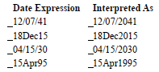

* How Four-Digit Years Are Handled

A date value that contains a four-digit year value will be interpreted correctly even if it does not fall within the 100-year span set by the **YEARCUTOFF** = system option.

* 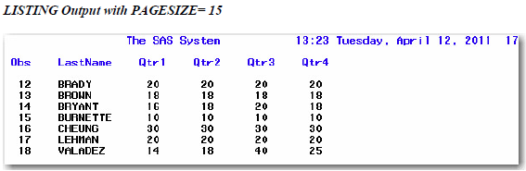Using System Option to Specify Observations

Basic code:

**FIRSTOBS** = n (Start point) / **OBS** = n (Ends point)

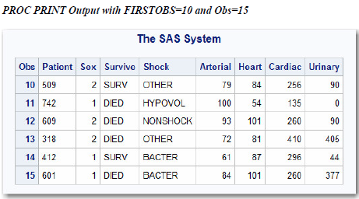By default, **FIRSTOBS**=1 and **OBS**= is MAX

Eg: **OPTION FIRSTOBS** =10 **OBS** =15;

**PROC** **PRINT** data=sasuser.heart;

**RUN**;

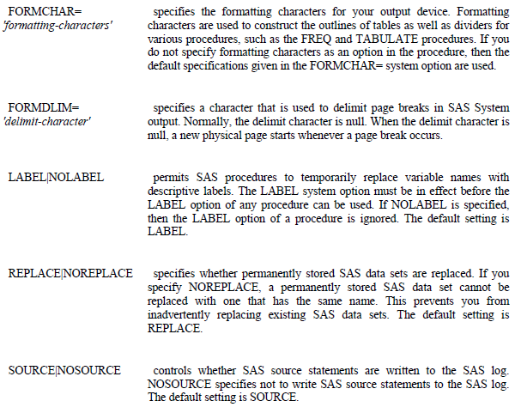

练习

1. How can you create SAS output in HTML format on any SAS platform?
2. by specifying system options

You can create HTML output using programming statements on any SAS platform. In addition, on all except mainframe platforms, you can use SAS windows to specify HTML as a result format.

1. by using programming statements
2. by using SAS windows to specify the result format
3. you can't create HTML output on all SAS platforms
4. When you specify an engine for a library, you always specify

A SAS engine is a set of internal instructions that SAS uses for writing to and reading from files in a SAS library. **Each engine specifies the file format for files that are stored in the library**, which in turn enables SAS to access files with a particular format. Some engines access SAS files, and other engines support access to other vendors' files.

1. the file format for files that are stored in the library.
2. the version of SAS that you are using.
3. access to other software vendors' files.
4. instructions for creating temporary SAS files.
5. Which statement prints a summary of all the files stored in the library named Area51?
6. **PROC CONTENTS** data=area51._**ALL**_ **NODS**;
7. **PROC CONTENTS** data=area51 _ **ALL** _ **NODS**;
8. **PROC CONTENTS** data=area51 _ **ALL** _ **NOOBS**
9. **PROC CONTENTS** data=area51 _ **ALL** _. **NODS**;
10. The following **PROC PRINT** output was created immediately after **PROC TABULATE** output. Which system options were specified when the report was created?



Clearly, the **DATE** and **NUMBER** (page number) options are specified. Because the page number on the output is 1, even though **PROC** **TABULATE** output was just produced, **PAGENO**=1 must also have been specified. If you don't specify **PAGENO**=, all output in the Output window is numbered sequentially throughout your SAS session.

1. **OBS**=, **DATE**, and **NONUMBER**
2. **NUMBER**, **PAGENO**=1, and **DATE**
3. **NUMBER** and **DATE** only
4. none of the above
5. Assuming you are using SAS code and not special SAS windows, which one of the following statements is *false*?
6. **LIBNAME** statements can be stored with a SAS program to reference the SAS library automatically when you submit the program.

The **LIBNAME** statement is global, which means that librefs remain in effect until you modify them, cancel them, or end your SAS session. Therefore, the **LIBNAME** statement assigns the libref for the current SAS session only. You must assign a libref before accessing SAS files that are stored in a permanent SAS data library.

1. When you delete a libref, SAS no longer has access to the files in the library. However, the contents of the library still exist on your operating system.
2. Librefs can last from one SAS session to another.
3. You can access files that were created with other vendors' software by submitting a **LIBNAME** statement.
4. What does the following statement do?

**LIBNAME** osiris SPSS 'c:\myfiles\sasdata\data.spss';

In the **LIBNAME** statement, you specify the **library name before the engine name**. Both are followed by the path.

1. defines a library called Spss using the OSIRIS engine
2. defines a library called Osiris using the SPSS engine
3. defines two libraries called Osiris and Spss using the default engine
4. defines the default library using the OSIRIS and SPSS engines